

Mathematics Specialist Year 11

Student name: _______________________Teacher name: ______________

Date: Friday 23rd July 2021

Task type: Response

Time allowed: 45 minutes

Number of questions: 6

Materials required: Calculator with CAS capability (to be provided by the student)

Standard items: Pens (blue/black preferred), pencils (including coloured), sharpener, correction fluid/tape, eraser, ruler, highlighters

Special items: Drawing instruments, templates, notes on two unfolded sheets of
A4 paper, and up to three calculators approved for use in the WACE examinations

Marks available: 40 marks

Task weighting: 10%

Formula sheet provided: Yes

Note: All part questions worth more than 2 marks require working to obtain full marks.

- [7 marks]
Use mathematical induction to prove that
$$3×5+6×6+9×7+…+3n\left(n+4\right)=\frac{n\left(n+1\right)\left(2n+13\right)}{2}$$
for all positive integers $n$.
Solution
Let $P(n)$ denote the proposition ‘$3×5+6×6+9×7+…+3n\left(n+4\right)=\frac{n\left(n+1\right)\left(2n+13\right)}{2}$’ for all positive integers $n$.

With $n=1$,
$$LHS of P\left(1\right)= 3×5 \\ =15$$

$$RHS of P(1)=\frac{1(1+1)(2×1+13)}{2} \\ =15$$
Hence LHS=RHS, and so $P(1)$ is true.

Now assume that $P(k)$ is true for some positive integer $k$. Then
$$3×5+6×6+9×7+…+3k\left(k+4\right)=\frac{k\left(k+1\right)\left(2k+13\right)}{2}.$$
Now
$$LHS of P\left(k+1\right)=3×5+6×6+9×7+…+3k\left(k+4\right)+3(k+1)(\left(k+1\right)+4) \\ =\frac{k\left(k+1\right)\left(2k+13\right)}{2}+3(k+1)(\left(k+1\right)+4) \\ =\frac{k\left(k+1\right)\left(2k+13\right)}{2}+3(k+1)(k+5) \\ =\frac{k\left(k+1\right)\left(2k+13\right)}{2}+\frac{6\left(k+1\right)\left(k+5\right)}{2} \\ =\frac{k\left(k+1\right)\left(2k+13\right)+6\left(k+1\right)\left(k+5\right)}{2} \\ =\frac{\left(k+1\right)[k\left(2k+13\right)+6\left(k+5\right)]}{2} \\ =\frac{\left(k+1\right)(2k^{2}+19k+30)}{2} \\ =\frac{\left(k+1\right)(k+2)(2k+15)}{2} \\ =\frac{\left(k+1\right)((k+1)+1)(2(k+1)+13)}{2} \\ =RHS of P(k+1)$$
Hence $P(k+1)$ is true.

We have shown that $P(1)$ is true, and that if $P(k)$ is true for some positive integer $n$ then $P(k+1)$ is also true. Hence, by the principle of mathematical induction, $P(n)$ is true for all positive integers $n$.

Specific behaviours
proves $P(1)$ by evaluating LHS and RHS separately
assumes $P(k)$ is true
writes LHS of $P(k+1)$ using RHS of $P(k)$
simplifies expression algebraically to one fraction
writes numerator with a factor of $(k+1)$
obtains expression for RHS of $P(k+1)$ written in terms of $k+1$
writes conclusion for whole proof (accept just the second sentence without the first)

- [2 marks]
A question in a Specialist exam paper asked students to prove the following statement:
‘$3n$ is odd if and only if $n$ is odd (where $n$ is an integer)’.
One student wrote the answer below. Explain clearly why they should not receive full marks for this answer.

Proof:
We prove the contrapositive. Assume that $n$ is an even integer. Then $n=2k$ for some integer $k$. Now
$$3n=3\left(2k\right) \\ =2\left(3k\right)$$

which is even since $3k$ is an integer. Hence if $n$ is even then $3n$ is even, which implies that $3n$ is odd if and only if $n$ is odd.
Solution
The student has proved only the statement ‘if $3n$ is odd then $n$ is odd’. However, since the original statement involves the phrase ‘if and only if’, it is also necessary to prove the statement ‘if $n$ is odd then $3n$ is odd’.

Specific behaviours
Notes that statement involves ‘if and only if’, or describes as an equivalence statement
Explains that the student should also have proved that ‘if $n$ is odd then $3n$ is odd’, or refers to the ‘backward direction’

- [9 = 3+3+3 marks]
Write whether each of the following statements is true or false, and prove or disprove it accordingly.

- For all positive real numbers $x$
$$x^{3}-x≥x^{2}-x$$
Solution
The statement is false, and is disproved with the following counterexample:

Let $x=\frac{1}{2}$. Then LHS = $\frac{1}{8}-\frac{1}{2}=-\frac{3}{8}$ and RHS = $\frac{1}{4}-\frac{1}{2}=-\frac{1}{4}$, meaning that $x^{3}-x<x^{2}-x$ in this case.

Hence the statement is false.

Specific behaviours
states false
states counterexample with a particular value of $x$
shows that for that value of $x$, $x^{3}-x<x^{2}-x$.

[Alternatively give 2nd and 3rd marks if successfully argues false for any value of $x$ with $0<x<1$.]

- There exist distinct prime numbers $p$ and $q$ such that $p-q=2$.
Solution
The statement is true, and is proved with the following example:

Let $p=5$ and $q=3$. Then $p-q=2$.
Specific behaviours
states true
states example with values of $p$ and $q$ such that $p-q=2$

- There exist distinct prime numbers$p$ and $q$ such that $p^{2}-q^{2}=2$.
Solution
The statement is false.

Let $p$ and $q$ be distinct prime numbers. Then
$$p^{2}-q^{2}=\left(p+q\right)\left(p-q\right)$$Since $p$ and $q$ are distinct primes, $p+q≥5$ and $p-q≥1$, and so $p^{2}-q^{2}≥5$.
Hence there do not exist distinct prime numbers $p$ and $q$ with $p^{2}-q^{2}=2$.

Specific behaviours
states false
factorises $p^{2}-q^{2}$ using difference of squares
argues that $p^{2}-q^{2}$ cannot equal $2$.

- [6 marks]
Find the values of $x,y$ and $z$ in each of the following:
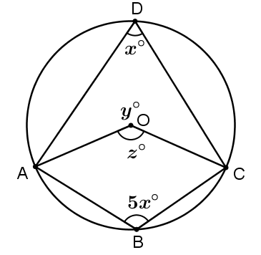
- $A, B, C$ and $D$ all lie on the circle with centre $O$:
Solution
$$5x+x=180 \\ x=30$$

$$z=2×30 \\ =60$$

$$y=360-60 \\ =300$$

Specific behaviours
1 mark per correct value

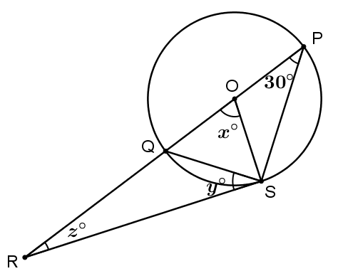
- $\overline{RS}$ is tangent to the circle with centre $O$.
Solution
$$x=2×30 \\ =60$$

$$y=30$$

$$z=180-90-60 \\ =30$$

Specific behaviours
1 mark per correct value

- [5 marks]
$ABCD$ is a quadrilateral such that each of the four sides is tangent to the same circle, at the points $P,Q,R$ and $S$, as illustrated below. If $AB=15$, $BC=10$ and $CD=12$, find the length $AD$.
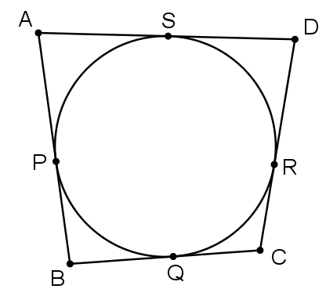
Solution
Since the sides are tangent to the circle, we may write:

$w=AS=AP$, $x=BQ=BP$, $y=CQ=CR$ and $z=DS=DR$.

Thus
$w+x=15$ (1)
$x+y=10$ (2)
$y+z=12$ (3)
Adding equations (1) and (3) gives
$$w+x+y+z=27$$
and subtracting equation (2) gives
$$w+z=17$$
Hence $AD=17$.

Specific behaviours
uses theorem for tangent segments from the same point
identifies segments of equal lengths
sets up equations for side lengths using sums of segment lengths
solves set of equations for $w+z$
states correct value

[Accept alternative methods.]

- [11 = 3+4+4 marks]
Solve each of the following trigonometric equations for $x$ in the stated domain.
Show all working to support your answers.
- $2\cos\left(x\right)=\sqrt{3}$ for $0≤x≤2π$
Solution
$$2\cos\left(x\right)=\sqrt{3} \\ \cos\left(x\right)=\frac{\sqrt{3}}{2} \\ x=\frac{π}{6} or\frac{11π}{6}$$

Specific behaviours
isolates $cos⁡(x)$
states at least one correct solution
states two correct solutions
[No marks for answers only]

- $\sin\left(x+\frac{π}{4}\right)=-\frac{1}{\sqrt{2}}$ for $-π≤x≤π$
Solution
$$\sin\left(x+\frac{π}{4}\right)=-\frac{1}{\sqrt{2}} \\ x+\frac{π}{4}=\frac{5π}{4}+k2π \\ or x+\frac{π}{4}=\frac{7π}{4}+k2π$$
Hence
$$x=π+k2π$$
$$or x=\frac{3π}{2}+k2π$$

With $k=0$, $x=π$ or $x=\frac{3π}{2}$
With $k=-1$, $x=-π$ or $x=-\frac{π}{2}$

Hence $x=-π,-\frac{π}{2}$ or $π$

Specific behaviours
isolates $\sin\left(x+\frac{π}{4}\right)$
states at least one correct solution for $x+\frac{π}{4}$
states at least one correct solution or for $x$
states all three correct solutions for $x$
[No marks for answers only]

- $\frac{1}{\sqrt{3}}\tan{(5x)}=1$ for $0≤x≤π$
Solution
$$\tan\left(5x\right)=\sqrt{3} \\ 5x=\frac{π}{3}+kπ \\ x=\frac{π}{15}+k\frac{π}{5}$$

Letting $k=0,1,2,3$ and $4$ we obtain:
$x=\frac{π}{15},\frac{4π}{15},\frac{7π}{15},\frac{10π}{15}$ and $\frac{13π}{15}$

Specific behaviours
isolates $\tan\left(5x\right)$
obtains $\frac{π}{3}$ as a solution for $5x$
obtains $\frac{π}{15}$ as a solution for $x$
states all five correct solutions for $x$
[No marks for answers only]

